Design and Implementation of Zero-Overhead Hardware Looping and Vmac in a MIPS Processor
Authors: Evyatar Shapira, Michael Kochubey, Shay Dahan
Date: January 17, 2026
Course: Computer Hardware Structure and Design
1. Introduction and Objective
Standard RISC processors, like the MIPS architecture, manage repetitive tasks using software loops. A typical loop involves instructions to perform the actual calculation, followed by "overhead" instructions to decrement a loop counter and conditionally branch back to the start. This overhead wastes processor cycles, fetching and decoding instructions that do not contribute directly to the computation.
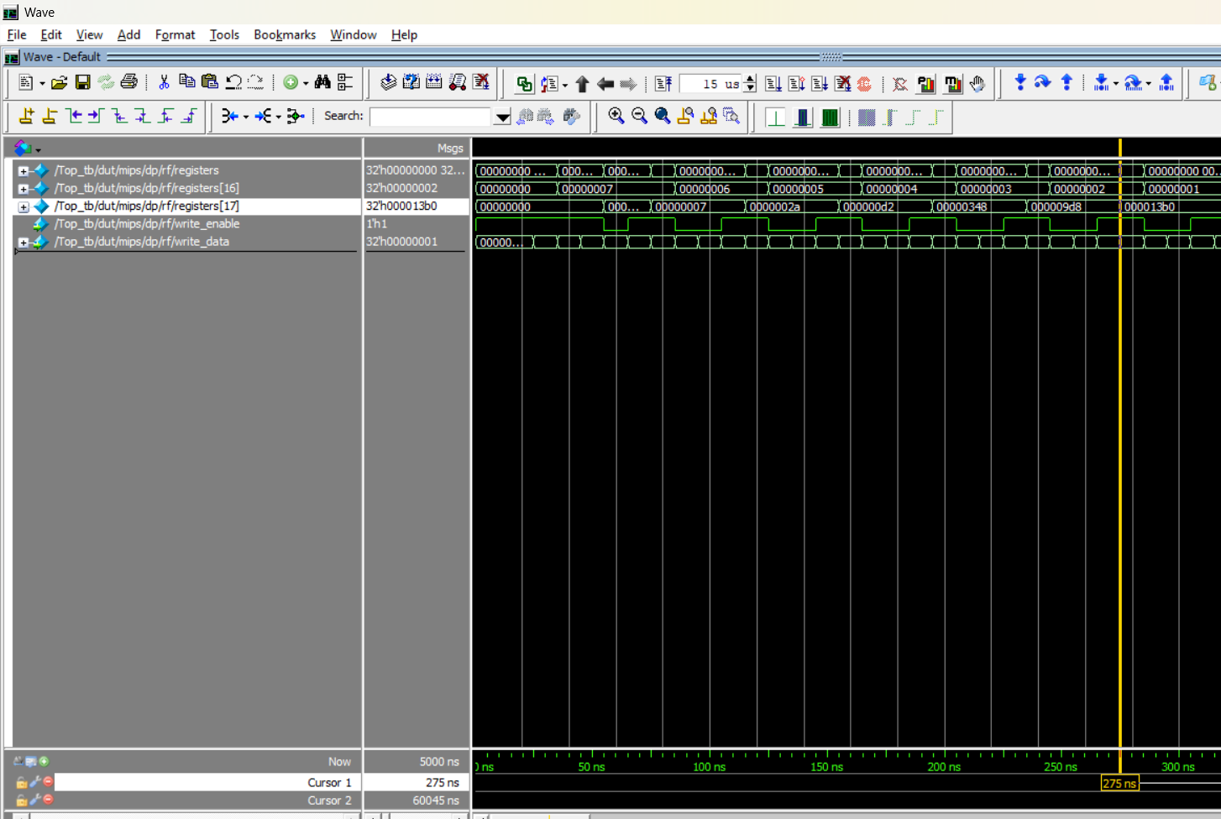
The objective of this project is to design, implement, and verify an enhanced MIPS processor capable of "Zero-Overhead Looping." By moving the loop management logic from software instructions into dedicated hardware registers and control paths, the processor aims to execute loop bodies in a single cycle per iteration, significantly improving performance for iterative workloads like digital signal processing.
Basic MIPS processor calculation for 7!:
Figure 1: Basic calculation of 7!
registers(17): 1 → 7 → 42 → 210 → 840 → 2520 → 5040 (0x13B0)
registers(16) - Shows count down: 7 → 6 → 5 → 4 → 3 → 2 → 1 → 0

2. Benchmark Methodology
To evaluate the performance improvement, a specific Vector Multiply-Accumulate (VMAC) benchmark was devised. Both the baseline (standard MIPS) and enhanced processors were tasked with executing the following calculation 1,000 times:
Equation per iteration:
Result = (A * B) + (C * D)
Test Vectors:
- A = -18 (stored in upper half of Register 2)
- B = 38 (stored in upper half of Register 3)
- C = 44 (stored in lower half of Register 2)
- D = 5 (stored in lower half of Register 3)
Expected Calculation:
(-18 * 38) + (44 * 5) = -684 + 220 = -464
Total Accumulated Result (1000 iterations):
-464 * 1000 = -464,000
(Hexadecimal Value: 0xFFF8EB80)
Verification of this final value in both processors ensures that the architectural changes did not alter the correctness of the computations.
3. Architectural Implementation Comparison
This section details the differences between the baseline architecture and the hardware-accelerated implementation.
3.1 Baseline Architecture (Software Loop)
The baseline processor uses standard MIPS instructions. The loop is managed entirely by software instructions (ADDI for decrementing and BNE for branching).
Software Loop Assembly (Instruction Memory):
As shown below, for every single iteration of math, the processor must execute 6 separate instructions. 4 of these are overhead that do not contribute to the result.
Verilog
// From InstrMem.sv (Old Processor)
// --- Loop Body ---
5: instr = 32'h0043401C; // MUL $8, $2, $3 (Math: Term 1)
6: instr = 32'h00C7481C; // MUL $9, $6, $7 (Math: Term 2)
7: instr = 32'h01095020; // ADD $10, $8, $9 (Math: Sum Terms)
8: instr = 32'h002A0820; // ADD $1, $1, $10 (Math: Accumulate)
// --- Overhead ---
9: instr = 32'h2084FFFF; // ADDI $4, $4, -1 (Overhead: Decrement Counter)
10:instr = 32'h1480FFFA; // BNE $4, $0, -6 (Overhead: Branch back)
- Cycles per iteration: 6
3.2 Enhanced Architecture (Hardware Loop)
The enhanced processor introduces custom hardware and instructions to eliminate overhead.
- LOOP Instruction: A new instruction that initializes an internal hardware loop counter.
- VMAC Instruction: A custom DSP instruction that performs the multiply-accumulate operation in a single cycle.
- Hardware Controller: A dedicated logic block in the DataPath monitors the program counter. It automatically decrements the hardware counter and resets the PC to the start of the loop without fetching a branch instruction.
Hardware Loop Assembly (Instruction Memory):
The software is reduced to a setup instruction and a single computation instruction.
Verilog
// From prog_vmac_1000.txt (New Processor)
// --- Setup ---
7: FC800000 // LOOP R8 (Initialize hardware counter with 1000)
// --- Loop Body ---
8: 70430819 // VMAC R1, R2, R3 (Perform ALL math in 1 cycle)
- Cycles per iteration: 1 (after setup)
4. Simulation Results and Performance Analysis
Both processors were simulated in ModelSim for the full 1,000 iterations at a clock period of 10ns.
4.1 Correctness Verification
Both simulations successfully yielded the required final accumulator value of 0xFFF8EB80 (-464,000), validating that the math logic is correct in both designs.
4.2 Timing Results
Baseline Processor Waveform
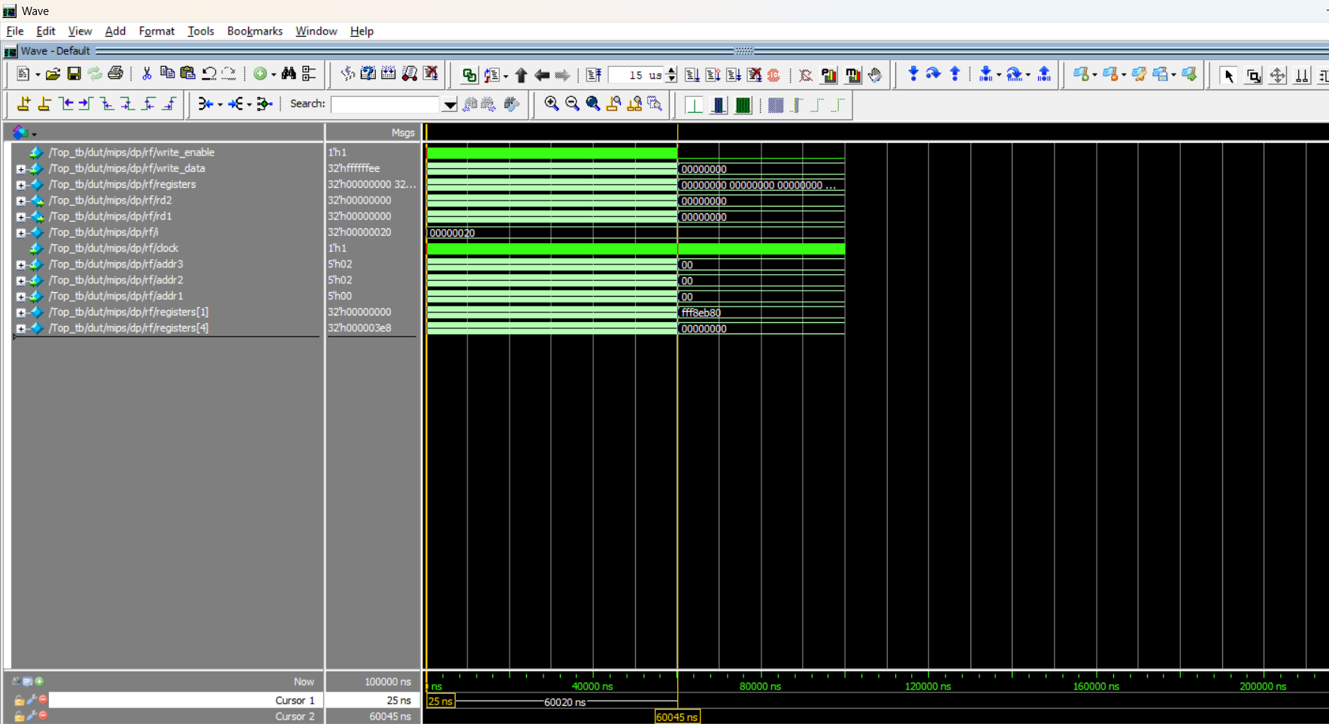
The baseline processor required approximately 60,020 ns to complete the task.
Figure 2: Baseline processor simulation completing in ~ 60,020 ns.
Enhanced Processor Waveform
The enhanced processor required only 10,070 ns to complete the same task.
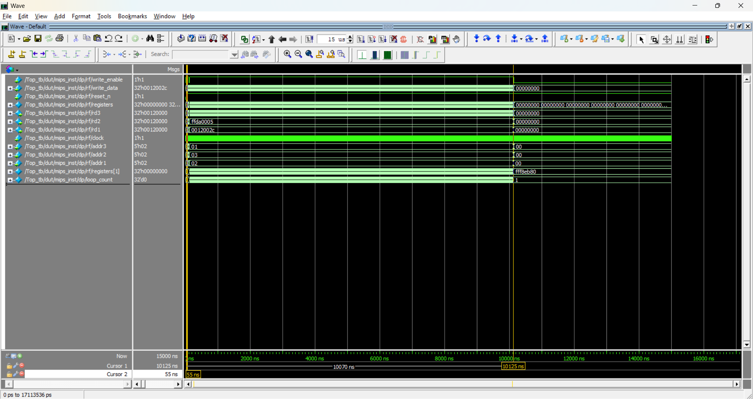
Figure 3: Enhanced processor simulation completing in ~ 10,070 ns.

4.3 Performance Comparison Table
Metric | Baseline Processor (Software Loop) | Enhanced Processor (Hardware Loop)
Instructions per Loop | 6 | 1
Total Cycles (1000 iter) | 6,002 | 1,007
Total Time (10ns clock) | 60,020 ns | 10,070 ns

4.4 Speedup Analysis
The speedup achieved by the hardware loop extension is calculated as the ratio of the execution times:
Speedup = (Execution Time_Old) / (Execution Time_New)
Speedup = 60,020 ns / 10,070 ns = 5.96
5. Conclusion
The implementation of zero-overhead hardware looping successfully removed the performance bottleneck associated with software-controlled branches. The results demonstrate a 5.96x performance improvement for the VMAC benchmark while maintaining computational accuracy. This confirms that moving control logic from software instructions into dedicated hardware datapaths is a highly effective optimization strategy for repetitive digital signal processing tasks.
6. New Processor Diagram
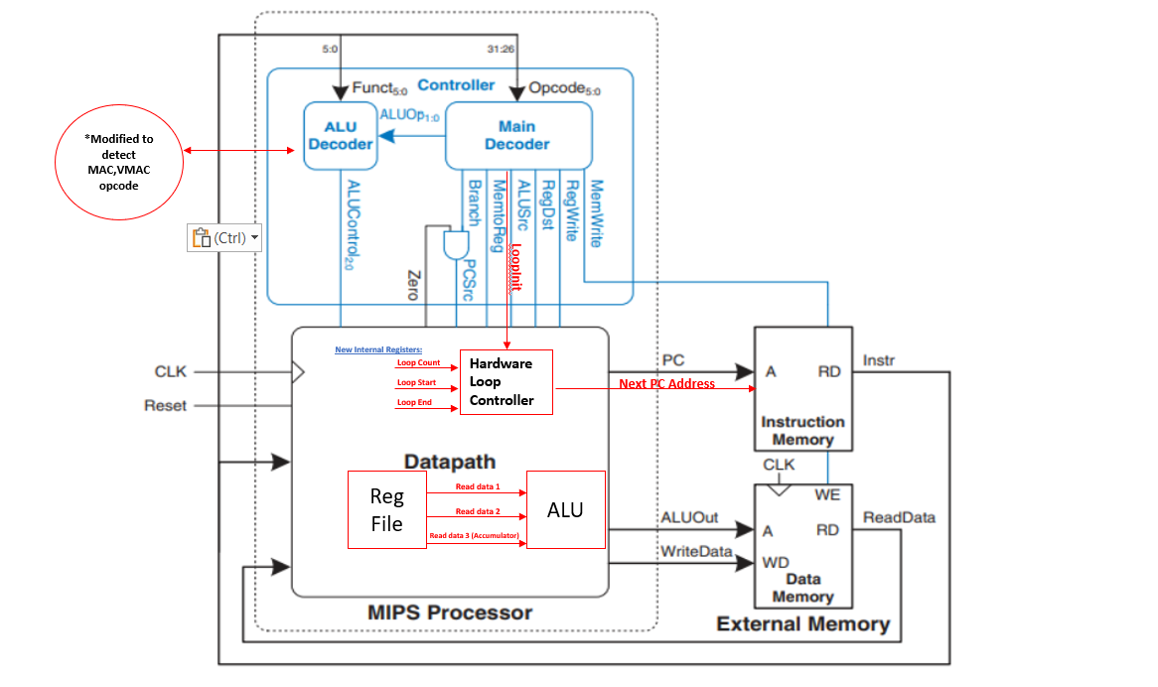
Figure 4: Enhanced processor block diagram

7. Appendix: System Architecture and Register Specification
7.1 System Overview
The designed system is a Single-Cycle MIPS Processor architecturally modified to support Digital Signal Processing (DSP) applications. The core enhancement is the integration of a Zero-Overhead Hardware Loop Controller and a Vector Multiply-Accumulate (VMAC) Unit. These additions allow the processor to execute iterative vector calculations with 100% cycle efficiency, eliminating the instruction fetch overhead associated with standard software-controlled loops.
7.2 Detailed System Components
A. Core Processing Units
- Top Module: The simulation wrapper connecting the processor core to the instruction and data memory units.
- MIPS Core: Encapsulates the Control Unit and DataPath, exposing the Program Counter (PC) and ALU results to the memory systems.
- Control Unit:
  - Main Decoder: Modified to decode the custom LOOP (Opcode 0x3F) and VMAC (Opcode 0x1C) instructions.
  - ALU Decoder: Updated to generate specific control signals for the split-word math operations.
  - Control Signals: Includes a new loop_init signal to trigger the hardware loop registers and bne logic for legacy support.
B. DataPath & Execution Units
- DataPath: The central processing block containing standard MIPS components (PC, Multiplexers) and the dedicated Hardware Loop Controller.
  - Loop Logic: Automatically monitors the Program Counter. If the loop is active (loop_count > 1) and the PC reaches the loop_end address, the controller overrides the PC to jump back to loop_start without fetching a branch instruction.
- ALU (Arithmetic Logic Unit): A modified execution unit supporting standard operations (ADD, SUB, OR) and the custom VMAC operation.
  - VMAC Operation: Accepts three inputs (src_a, src_b, src_c). It splits the 32-bit inputs into upper and lower 16-bit halves, multiplies them, and adds the accumulator value in a single clock cycle.
- Register File:
  - Three-Port Read: Expanded from the standard two ports to support three simultaneous read operations (rd1, rd2, rd3). This enables the processor to fetch two multiplicands and the accumulator register simultaneously.

C. Memory Units
- Instruction Memory: Stores the program code, including the specific VMAC benchmark instructions.
- Data Memory: Stores application data and initialization vectors. For the benchmark, it is pre-loaded with Input Vector A (0x0012002C), Input Vector B (0xFFDA0005), and the Loop Count (1000).
7.3 Register Specification
The system utilizes two distinct sets of registers: the programmer-visible General Purpose Registers and the internal Hardware Loop Registers.
A. General Purpose Registers (Programmer Visible)
These are the standard 32-bit MIPS registers located in the Register File, accessible via standard assembly instructions.
- Quantity: 32 Registers ($0 – $31).
- Width: 32-bits.
- Key Registers for VMAC Benchmark:
  - $0 (Zero): Hardwired to value 0.
  - $1 (Accumulator): Stores the running total of the VMAC calculation.
  - $2 (Input Vector A): Holds two packed 16-bit values (Upper: 18, Lower: 44).
  - $3 (Input Vector B): Holds two packed 16-bit values (Upper: -38, Lower: 5).
  - $4 (Loop Source): Used temporarily to load the immediate loop count (1000) before initialization.
B. Internal Hardware Loop Registers (Internal/Hidden)
These registers are located within the DataPath's Loop Controller and are not directly addressable by standard instructions. They are managed automatically by the hardware upon execution of the LOOP instruction.

Register Name | Width | Description
loop_count | 32-bit | Stores the remaining number of iterations. It is loaded by the LOOP instruction and decrements automatically every time the loop repeats.  +1
loop_start | 32-bit | Stores the memory address of the first instruction in the loop body. The PC jumps here automatically when the loop repeats.  +1
loop_end | 32-bit | Stores the memory address of the last instruction in the loop body. When the PC hits this address, the controller decides whether to loop back or continue.  +1

7.4 Instruction Set Extensions
The processor supports two custom instructions designed to accelerate DSP workloads.
1. LOOP Instruction
- Opcode: 0x3F (Binary 111111).
- Syntax: LOOP Rs
- Operation:
  - Loads the internal loop_count register with the value from General Purpose Register Rs.
  - Sets the internal loop_start register to PC + 4.
  - Sets the internal loop_end register to the branch target address.
2. VMAC Instruction (Vector Multiply-Accumulate)
- Opcode: 0x1C (Binary 011100).
- Syntax: VMAC Rd, Rs, Rt (Implicitly reads Accumulator from Rd).
- Operation: Performs a dual 16-bit signed multiplication and accumulation in a single cycle.
  - Result = Accumulator + (Rs[31:16] * Rt[31:16]) + (Rs[15:0] * Rt[15:0]).

